Medical Genetic
Dr. NOOR M. Awad
stage:3
Lec. 11

x linked inheritance
Sometimes, there is a change (mutation) in one copy of a gene which stops it from working properly. This change can cause agenetic condition because the gene is not communicating the correct instructions to the body. An X linked genetic condition is caused by a change in a gene on the X chromosome.

What is x linked recessive inheritance?
The X chromosome has many genes that are important for growth and development. The Y chromosome is much smaller and has fewer genes. Females have two X chromosomes (XX) and therefore if one of the genes on an X chromosome has a change, the normal gene on the other X chromosome can compensate for the changed copy. If this happens the female is usually a healthy carrier of the X linked condition. Being a carrier means that you do not have the condition, but carry a changed copy of the gene. In some cases, females show mild signs of the condition.
Males have an X and a Y chromosome (XY) and therefore if one of the genes on the male’s X chromosome has a change, he does not have another copy of that gene to compensate for the changed copy. This means that he will be affected by the condition. Conditions that are inherited in this way are called X linked recessive conditions. Some examples of X linked conditions include haemophilia, Duchenne muscular dystrophy and fragileX.

X linked dominant inheritance
Though most X linked conditions are recessive, very rarely X linked conditions can be passed on in a dominant way. This means that even though a female inherits one normal copy and one changed copy of the gene, the changed gene will be enough to cause the condition. If a male inherits a changed X chromosome then this would be enough to cause the condition because males only have one X chromosome. An affected female has a 50% (1 in 2) chance of having affected children (sons and daughters). An affected male will have all daughters affected but all sons will be unaffected.

How are X linked recessive conditions inherited?
If a female carrier has a son, she will pass on either the X chromosome with the normal gene, or the X chromosome withthe changed gene. Each son therefore has a 50% chance (1 in2) of inheriting the changed gene and being affected by the condition. There is also a 50% chance (1 in 2) that the son will inherit the normal gene. If this happens he will not be affected by the condition. This chance remains the same for every son.
If a male who has an X linked condition has a son, his son will never inherit the changed gene on the X chromosome. This is because men always pass on their Y chromosome to their sons (if they passed on their X chromosome they would have a daughter).

Picture 3: How X linked recessive conditions are passed on by female carriers
Normal gene
Changed gene
Carrier female Unaffected male
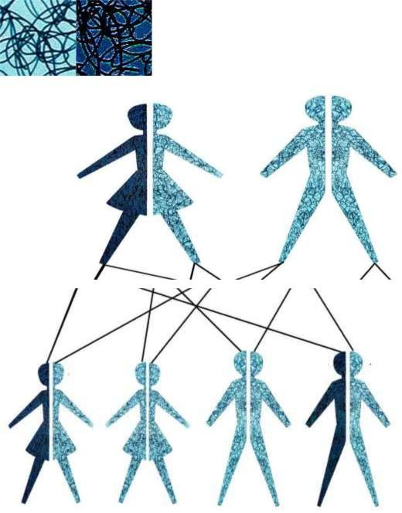

Carrier female/ Unaffected female/ Affected male/ affected male

Picture 4: How X linked recessive conditions are passed on by affected males
Normal gene Affected male Unaffected female Changed gene
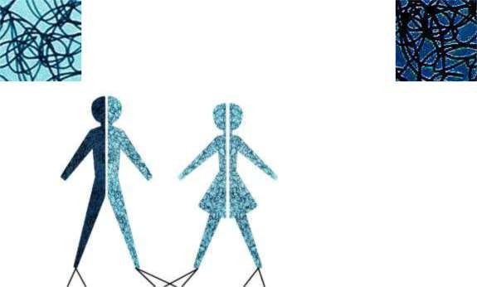

Carrier female/ Carrier female/ Unaffected male/ Unaffected male

If a male who has an X linked condition has a daughter, he will always pass on the changed gene to her. This is because males only have one X chromosome and they always pass this on to their daughters. All his daughters will therefore be carriers. The daughters will usually not have the condition, but they are at risk of having affected sons.
If a male who has an X linked condition has a son, his son will never inherit the changed gene on the X chromosome. This is because men always pass on their Y chromosome to their sons (if they passed on their X chromosome they would have a daughter).
What if a child is the first person in the family to have the condition? Sometimes a child born with an X linked genetic condition can be the first person to be affected in the family. This may happen because a new gene change has occurred for the first time in the egg or sperm that created the baby. When this happens, neither parent of that child is a carrier. The parents are very unlikely to have another child affected by the same condition. However the affected child, who now has the changed gene, can pass it on to their children.

Carrier Testing and Tests in Pregnancy
A number of options may be available for people who have a family history of an X linked genetic condition. Carrier testing may be available for females to see if they are carriers of the changed gene. This information may be useful when planning pregnancies. For some X linked conditions it is possible to have a test in pregnancy to see if the baby has inherited the condition (more information about these tests are available in the CVS and amniocentesis leaflets). This is something you should discuss with your doctor or healthcare professional.

Points to remember
- Female carriers have a 505 chance of passing on a changed gene. If a son inherits a changed gene from his mother, then he will be affected by the condition. If a daughter inherits a changed gene she will be a carrier like her mother.
- A male who has an X linked recessive condition will always pass on the changed gene to his daughter, who will then be a carrier. However if he has an X linked dominant condition his daughter will be affected. A male will never pass on a changed gene to his son.
- A changed gene cannot be corrected – it is present for life.
- A changed gene is not something that can be caught from other people. They can still be a blood donor, for example.
- People often feel guilty about a genetic condition which runs in the family. It is important to remember that it is noone’s fault and no-one has done anything to cause it to happen.

الصور المدرجة ادناه هي توضيح للمحاضرة:

